**Layers of a Rainforest**

[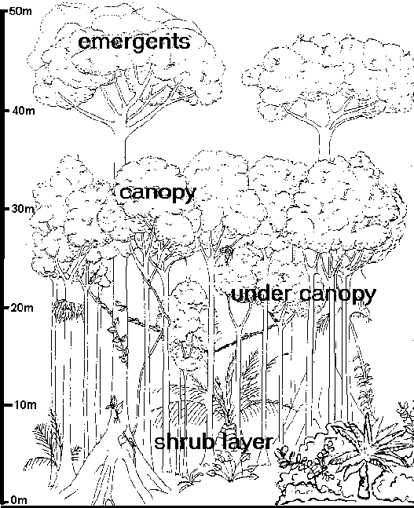](http://www.google.com.au/url?sa=i&rct=j&q=&esrc=s&frm=1&source=images&cd=&cad=rja&docid=5Sz2UY-PuMIlMM&tbnid=467-lZqeFSqTjM:&ved=0CAUQjRw&url=http://www.geography.learnontheinternet.co.uk/topics/rainforest.html&ei=J9z5UY6hHcWpkwXfi4GQDQ&bvm=bv.50165853,d.dGI&psig=AFQjCNF3uIuZCO-f9tBIHhrclvq6HqQQdw&ust=1375415711534272)