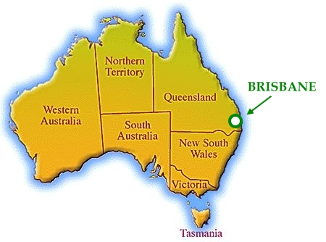
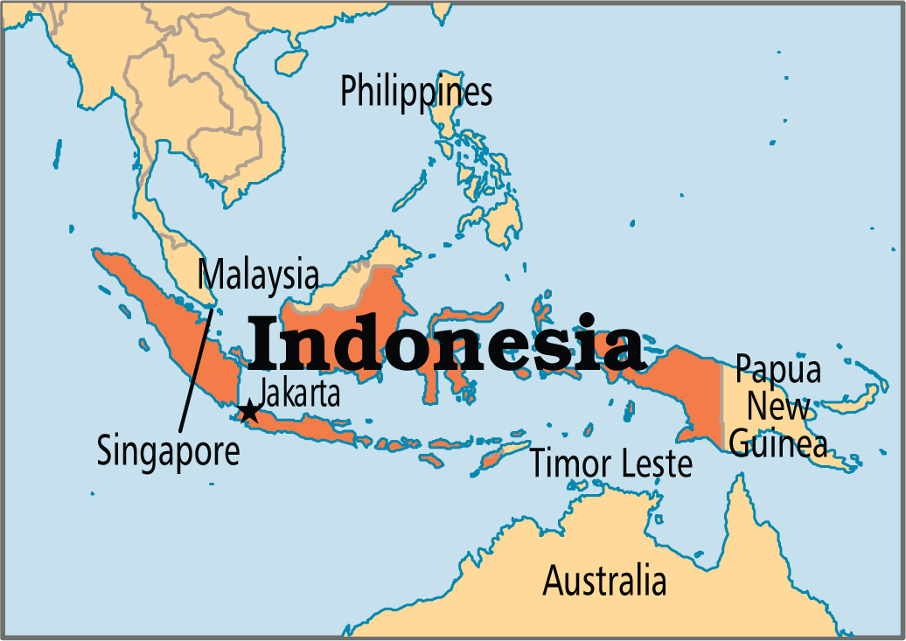
Guided Investigation

Similarities and Differences
Jakarta (Java, Indonesia)
and
Brisbane (Queensland, Australia)

Look at the climate graphs on myyear3.weebly.com.
Interpret the climate graph and map of the Asia Pacific region to answer questions below
Questions | Jakarta | Brisbane
Where is the place located in relation to Australia?
Where is the place located in relation to the Tropic of Caporicorn?
What is the hottest month?
What is highest temperature in the hottest month?
What is the coldest month?
What is the lowest temperature in the coldest month?
What is the wettest month?
What is the driest month?
What is the average rainfall of the driest month?
Why is the hottest month in Jakarta not during summer? (Look the rainfall graph for clues)
Interprets climate graphs to identify temperature and rainfall patterns. MARK _____

Develop at least 3 geographical questions about the countries of the places
Conduct research to answer and record these questions
Your questions to investigate  E.g. What languages to they speak? | Jakarta | Brisbane
Poses geographical questions to investigate. MARK _____
Collects and records geographical information from sources to answer questions. MARK _____
Represent your findings in a Venn diagram to show similarities and differences between the countries

Indonesia Australia

Write a paragraph explaining the why you think there are similarities and differences.
_____________________________________
_____________________________________
_____________________________________
_____________________________________
_____________________________________
_____________________________________
_____________________________________
_____________________________________
Gives reasons for the similarities and differences between different places. MARK ___

