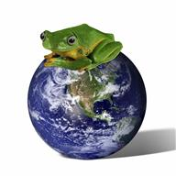
Date:__________

__________’s Rainforest Diorama Plan

- What do you want your diorama to show in these layers (keep adding more as you learn more):

 | Plants | Animals
Emergent Layer
Canopy
Understory
Forest Floor
2. How are you going to make your plants? (e.g. strangler figs, ferns, fungi, vines etc) DRAW or WRITE ideas below

3. How are you going to make your animals? (e.g. green tree frogs, snakes, birds, etc) DRAW or WRITE ideas below

4. Make a list of things you need to build your diorama.
- -
- -
- -
- -
- -
- -
- -
- -

5. Draw a picture of what you want your diorama to look like (don’t forget to label it!)

