Using Google Maps, label Australia and it’s neighbouring countries
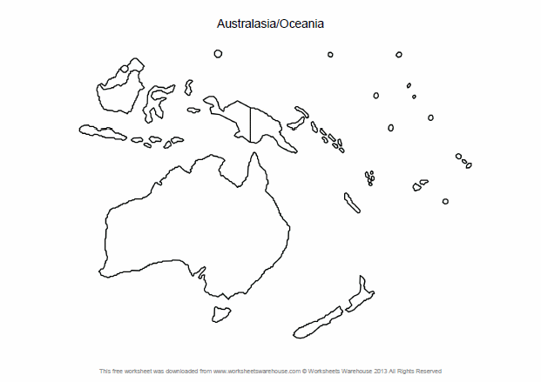

Australia’s Neighbours
Indonesia
Papua New Guinea
Timor Leste
New Zealand
Solomon Islands
Fiji
New Caledonia

