Year 3 Term 2 History

Assessment Booklet: Bankfoot House

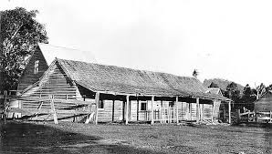

Not enough people know about the history of Bankfoot House.
If we don't let them know, who will?

PART A Timeline
PART B Explanation
PART C Drawings and Comparisons

NAME: ____________________________

PART A – Timeline

Your task is to create a visually attractive timeline showing important events that impacted upon Bankfoot House's history.

You will complete this task in class time.
A timeline will be chosen to send to the Friends of Bankfoot House for them to use to help educate the community.

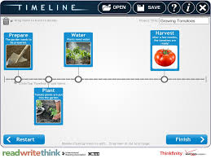
This is the type of timeline you will create on the iPad (only not on gardening!)
Success Criteria
- All important events listed (highlight important events on the detailed timeline given on the next couple of pages. Remember, don’t include everything)
- Starts just before the Gympie Gold Rush
- Finishes just after the time the Post Office was moved from Bankfoot House to Glasshouse
- Picture for each event
- Timeline printed and pasted neatly into History Book

History of Bankfoot House – Detailed Timeline
Use this timeline to help you plan your own.

- Highlight what events you want to include on your timeline
- Don’t forget to include the original land owners - the Gubbi Gubbi people

1834 | Mary Fenwick born in a small village in Bankfoot, Scotland
1855 | Mary travelled with her family to Australia by ship and began a romance with fellow Scotsman William Grigor.
1859 | Mary working as a governess and leaves Australia to travel to England with the family she is working for.
1842 | Bunya Proclamation: An area of bunya pine country north of Brisbane (Sunshine Coast) is reserved for Aborigines.
1860 | The order protecting the bunya pines and other trees in the sunshine Coast area is cancelled by the first Queensland Government.
1860’s | Population increases on the Sunshine Coast. Lots of timber is needed for building.
1863 | William and Mary marry at Eagle Farm Presbyterian Church, Brisbane. They move to Alexandra Headlands where William is cutting and hauling timber.
1867 | Gold is discovered in Gympie
1868 | New Brisbane to Gympie road is built to take people more quickly to the Goldfields.
1868 | William Grigor hears of the new Brisbane to Gympie road. He sees the business opportunity and builds a house on the road to serve the travellers going to the Goldfields.
1870’s | Bankfoot House is a major community centre operating as a post office, butchery, dairy, shop and horse change and meal stop for the Cobb & Co coaches.
1878 | Added another building behind original house for more bedrooms and a kitchen.
1891 | Railway line opens and coaches stop travelling from Brisbane
1907 | William Grigor passes away and stops delivering the mail to the train. Glasshouse Mountains railway station becomes the new post office.
1930 | The Depression. 1 in 3 people have no work so people have little money. Building and tourism is affected.
1930’s | The original accommodation house at Bankfoot has deteriorated and there is no money to fix it. They decide to demolish it and rebuild a new house out of the materials.
1930’s | Less people visiting Bankfoot House now as other roads are more popular. More tourists come now to climb the Glasshouse Mountains.

PART B – Explanation
How did the development of transport cause changes in Bankfoot House and the Glasshouse Community?

Write a clear explanation below.
____________________________________________________________________________________________________________________________
____________________________________________________________________________________________________________________________
____________________________________________________________________________________________________________________________
_______________________________
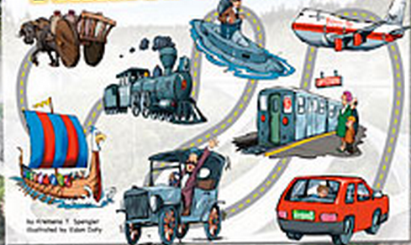

PART C – Drawings and Comparisons
Draw the Glasshouse landscape before Bankfoot house was built

Draw Glasshouse Mountains or Beerwah township today

List things that have changed  (Use dot points) | List things that have stayed the same.  (Use dot points)

